Distributive Numerals

✅ Definition:
# Source: AI Source: Provided by: [Data Path: Persons Table -> ID Column: 1, Name_En Column: Motasem Essam] -> From: [Chatgpt (GPT-4-turbo)] on [7/28/2025]
Distributive numerals express distribution of quantity — that is, how something is divided or assigned individually to members of a group.
They answer questions like:
- "How many each?"
- "To each one?"
- "In what portion per item/person?"

🧩 Common Distributive Numerals:
# Source: AI Source: Provided by: [Data Path: Persons Table -> ID Column: 1, Name_En Column: Motasem Essam] -> From: [Chatgpt (GPT-4-turbo)] on [7/28/2025]
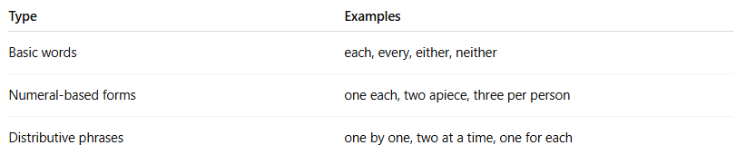
Type | Examples
Basic words | each, every, either, neither
Numeral-based forms | one each, two apiece, three per person
Distributive phrases | one by one, two at a time, one for each

✏️ Examples in Sentences:
# Source: AI Source: Provided by: [Data Path: Persons Table -> ID Column: 1, Name_En Column: Motasem Essam] -> From: [Chatgpt (GPT-4-turbo)] on [7/28/2025]
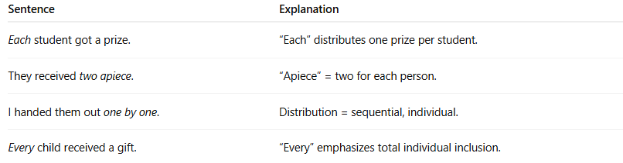
Sentence | Explanation
Each student got a prize. | “Each” distributes one prize per student.
They received two apiece. | “Apiece” = two for each person.
I handed them out one by one. | Distribution = sequential, individual.
Every child received a gift. | “Every” emphasizes total individual inclusion.

📌 Grammatical Functions:
# Source: AI Source: Provided by: [Data Path: Persons Table -> ID Column: 1, Name_En Column: Motasem Essam] -> From: [Chatgpt (GPT-4-turbo)] on [7/28/2025]
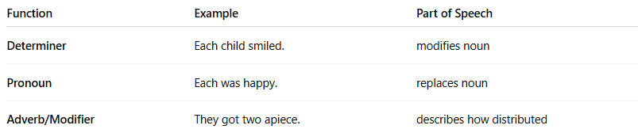
Function | Example | Part of Speech
Determiner | Each child smiled. | modifies noun
Pronoun | Each was happy. | replaces noun
Adverb/Modifier | They got two apiece. | describes how distributed

🔍 Properties of Distributive Numerals:
# Source: AI Source: Provided by: [Data Path: Persons Table -> ID Column: 1, Name_En Column: Motasem Essam] -> From: [Chatgpt (GPT-4-turbo)] on [7/28/2025]
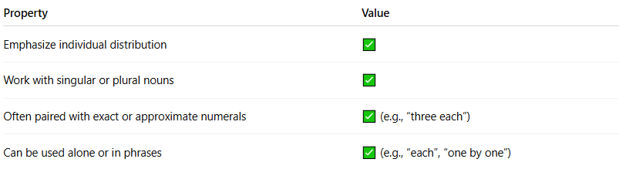
Property | Value
Emphasize individual distribution | ✅
Work with singular or plural nouns | ✅
Often paired with exact or approximate numerals | ✅ (e.g., “three each”)
Can be used alone or in phrases | ✅ (e.g., “each”, “one by one”)

⚠️ Note:
# Source: AI Source: Provided by: [Data Path: Persons Table -> ID Column: 1, Name_En Column: Motasem Essam] -> From: [Chatgpt (GPT-4-turbo)] on [7/28/2025]
- Distributive ≠ Cardinal:
  - Three = total count
  - Three each = three per individual
- Distributive ≠ Ordinal:
  - Third = sequence
  - Each = division across group
- Distributives often combine with other numerals.

🧠 Summary:
# Source: AI Source: Provided by: [Data Path: Persons Table -> ID Column: 1, Name_En Column: Motasem Essam] -> From: [Chatgpt (GPT-4-turbo)] on [7/28/2025]

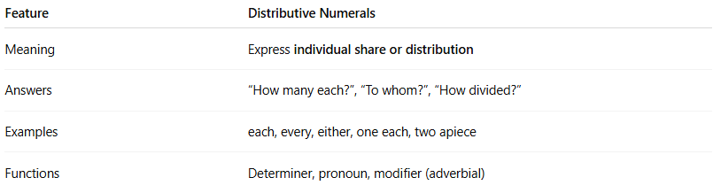
Feature | Distributive Numerals
Meaning | Express individual share or distribution
Answers | “How many each?”, “To whom?”, “How divided?”
Examples | each, every, either, one each, two apiece
Functions | Determiner, pronoun, modifier (adverbial)

